**Swinburne University of Technology**

**Data Visualisation**

**COS30045**

**Measuring Affordability: Visualizing Cost of Living Data from Around the World**

**Marco Giacoppo**

**Word Count : 2513 words S104071453**

# Executive Summary:

In order to illustrate patterns and trends, this research analyses the cost of living around the globe using data visualisations. The study examines elements like housing costs, grocery costs, healthcare costs, and transportation costs utilising a variety of data sources.

Recommendations include governments increasing access to affordable housing and public transportation, employers paying fair wages, and individuals making informed decisions about where to live and work.

The analysis shows that there are large regional and international differences in the cost of living. The research also demonstrates how cost of living statistics can be utilised to inform local, state, and federal policy choices as well as individual and family financial choices.

Ultimately, the research stresses the significance of knowing the cost of living in order to make better financial decisions for oneself and to inform societal policy that supports greater affordability and equity.

Table of Contents

Executive Summary: 2

Introduction: 4

Body: 6

What kind of data is used in the visualisation? 10

How is the data visually encoded? 11

Conclusion: 12

References: 13

# Introduction:

When examining the issue of cost of living, data visualisation can be a helpful tool for interpreting complex information. The amount of money needed to sustain a given standard of life in an area or region is known as the cost of living. According to Gould and Mokhiber (2022), it might vary significantly based on things like how much housing, food, transportation, medical care, and other costs cost.

The cost of housing is one of the most significant factors that affect the cost of living. Understanding how much of a person's salary is likely to be spent on housing in various locations can be done by both individuals and policymakers with the aid of statistics relating to the cost of housing. A bar chart can be used, for instance, to compare the typical monthly rent or least affordable housings across several cities or areas. It is simpler to compare the affordability of various regions when a chart like this one is used to demonstrate how much of a person's income is likely to be spent on housing in each location.

A significant contributor to the cost of living is food. Understanding how much it costs to maintain a healthy diet in various regions can be done by individuals and policymakers with the aid of data visualisation related to food costs. The average cost of groceries in various cities or areas can be plotted against the average income in each location, for instance, using a scatter plot. This chart can help individuals understand how the cost of food varies depending on where they live and how much they earn.

The cost of living is significantly influenced by transportation as well. Understanding how much it costs to go around in various regions can be made easier for people and policymakers using data linked to transportation expenses. A line chart, for instance, can be used to display the average cost of gas or public transit over time in various locations. This graph can be used to better understand how the cost of transportation varies over time and how it affects the cost of life.

A key contributing factor to the expense of living is healthcare. Individuals and decision-makers can better understand which healthcare services are most expensive and how they affect the overall cost of living by visualising data on healthcare expenditures. A stacked bar chart, for instance, can be used to display the average cost of healthcare in various regions, divided down by type of care.

The intended audience for cost-of-living visualizations can vary depending on the specific visualization and the purpose for which it is created. However, some common audiences for these visualizations may include:

1. Decision-makers in government: Cost of living visualisations can help with decisions about housing, transportation, healthcare, and other issues. These visualisations can help decision-makers at the local, state, and federal levels comprehend how proposed policies will affect the cost of living in various regions.
2. Researchers: Cost of living visualisations can be used by researchers in disciplines including economics, sociology, and public health to examine patterns and trends in the cost of living. These visuals can shed light on issues like income inequality, regional differences in the cost of living, and the influence of economic policies on these costs.
3. Journalists: Journalists can use cost of living visualisations to report on topics including home affordability, the effect of inflation on consumer prices, and the accessibility of healthcare services in various regions.
4. General Audiences: For cost-of-living visualisations, the general public can also be a target audience, especially if those visualisations are extensively shared on social media or in the media. Anyone can use these visualisations to understand and compare the cost of living in their own location and other places. They can also be used to guide decisions about one's own finances, such as whether to relocate to a cheaper city or region.

# Body:

Here are two illustrations of data visualisation utilising housing costs around the world. Users could compare the cost of rent in various regions of the world quickly by viewing these visualisations, enabling them to make well-informed judgements about where to live or invest. This kind of data visualisation would be especially helpful for companies wanting to enter new markets or for people thinking about moving for either personal or professional reasons.

## 

Figure 2: Countries with the highest Cost of Living Plus Rent Index in 2020.

Figure 1: Median House/ Apartment price divided by median annual gross income.

From *Figure 1*, we can see that real estate is notoriously pricey in large cities like San Francisco and Hong Kong. However, there are a lot of housing markets that you might not expect to be among the least affordable, including a number in Australia, New Zealand, and Canada. Three out of the ten least affordable housing markets are in Australia and New Zealand and four more are in the United States. The least affordable housing market is Hong Kong. The visualisation is encoded using position on scale, the longer the bar chart, the more expensive it is. Both of this visualisations uses quantitative data as it uses numbers.

Based on *Figure 2*, Zandt (2021 cited in Numbeo, 2020) discovered that despite Switzerland being around 12% less costly than New York City, it is still the most expensive place in the world to live in 2020. It's not the only place on the European continent where living costs are high, as our chart shows. The best estimates of the typical costs for a four-person family are taken into account by Numbeo's Cost of Living Index. These costs include everything from clothing, produce, and eating out to transportation, leisure activities, and utilities. The Rent Index takes into account estimates for renting one- and three-bedroom apartments in and outside of the city centre. This is also encoded using position on scale.

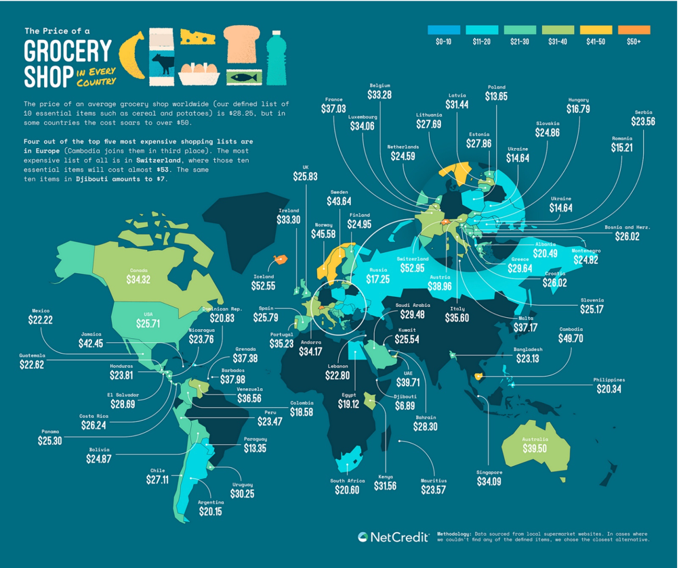

Figure 3: The prices of a grocery shop in various countries

In this visualisation, we can see that Switzerland has the most expensive essentials globally, costing $52.95 for a regular basket of groceries. The same groceries cost $6.89 in Djibouti, which is only 13% of the price in Switzerland. With this visualisation, we can see that they employed colours for encoding the data to show us which country has the highest grocery costs. With orange showing the most expensive ones, and blue showing the least expensive ones. It uses quantitative data as it shows the average costs of groceries around the world. This visualisation is composed well enough to let audiences understand fully of what’s going on. The colours on the countries and the lines showing the prices uses the right colours and it’s easily understandable.

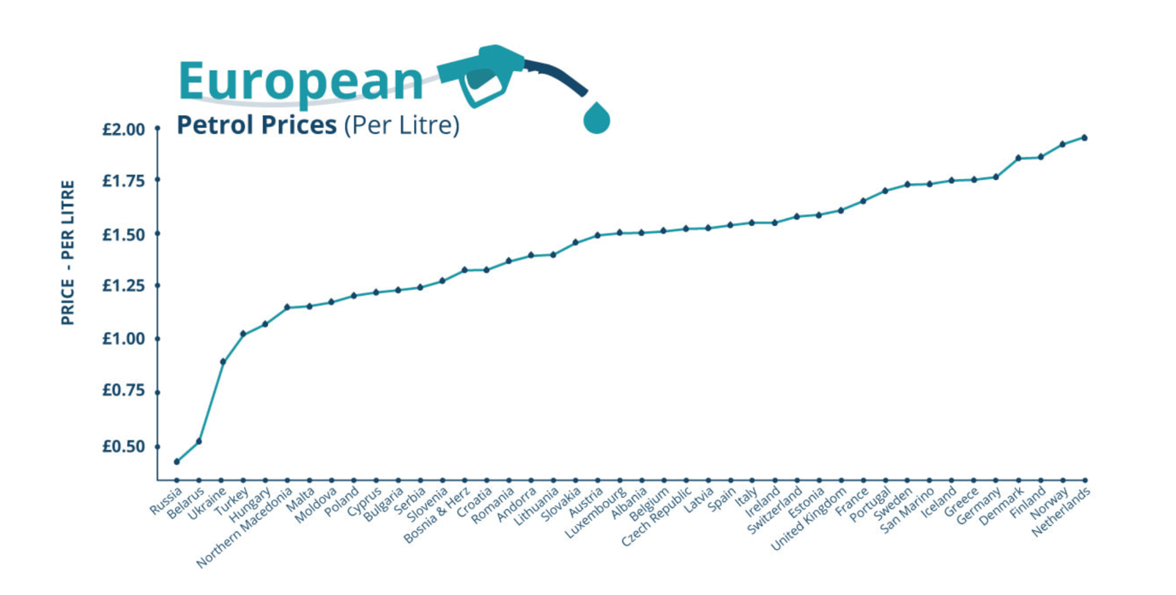

Figure 4: European petrol prices per litre

*Figure 4* shows a line graph of the price of gasoline in Europe. Using the data from globalpetrolprices.com, it shows 42 European countries, and where they rank for the price of their petrol (per litre) (per litre). It highlights the huge disparities of petrol costs between countries in Europe. We can see that the Netherlands leads the countries with the most expensive petrol in Europe, followed by Norway, Finland, Denmark, and Germany in fifth place. The average prices per litre uses numerical values, that’s why this visualisation also uses quantitative value. The visualisation is good enough to tell audiences the approximate costs of petrol between each country in Europe. One thing that can be improved is to lessen the countries or use a different type of chart to show the exact numbers, because with this chart it’s a bit hard to see the exact numbers between 42 countries.

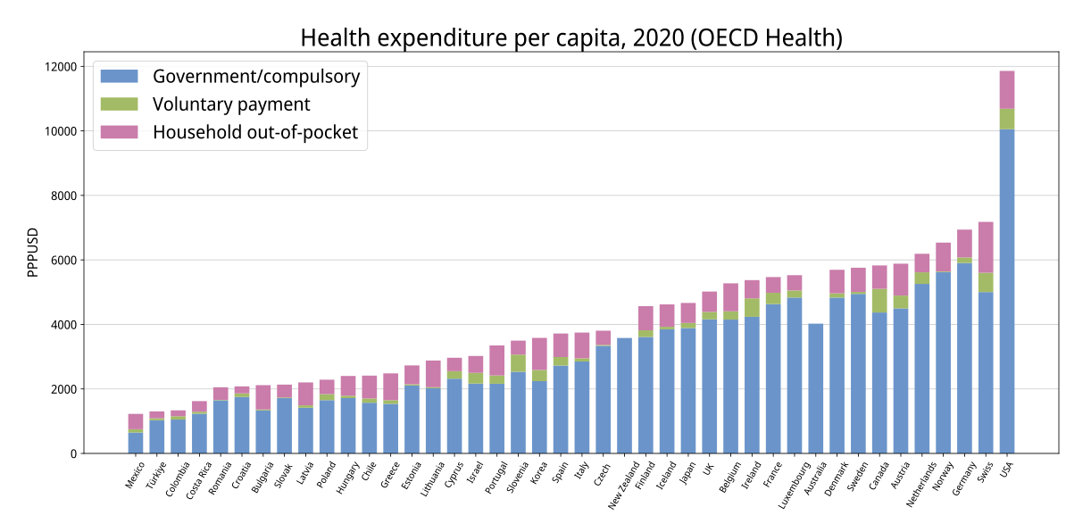

Figure 5: Health Expenditure per Capita, 2020

*Figure 5* is a stacked bar chart that breaks down voluntary spending further by separating out-of-pocket payments. In this chart the items are stacked by colour. This uses quantitative data and is encoded using colours and stacked bar chart to show the average cost of healthcare per capita. From the visualisation, we can see that most countries healthcare cost is between 2000 and 6000. Meanwhile, USA soars high to almost 12000. The data is calculated using economy-wide Purchasing Power Parity (PPP). PPP is a measurement of the rice of specific goods in different countries and is used to compare the absolute purchasing power of the country’s currencies.

From the chart above, we can see that the colour blue represents government/compulsory payment, the colour green shows voluntary payment, and the colour pink shows out-of-pocket payments. We can see that Australia and New Zealand are the only two countries that doesn’t use their own money for healthcare. Meanwhile, all the other countries use their own money or spends voluntary payments for their healthcare. From the figure above, it is visualised good enough to tell audiences the total costs of healthcare from each country. Some suggestions to make it more understandable is to write the percentage for each colour so we know from the total costs, how much each of the categories is.

## What kind of data is used in the visualisation?

There are several types of data used in the visualisations including:

* House Data: Data on housing may include information on the typical cost of rent or mortgage payments in various cities or areas. Data on housing affordability, such as the percentage of income normally spent on housing in a certain area, are also included. (Quantitative Data)
* Food data: This can contain information on the typical price of groceries, eating out, and other food-related costs in various locations. Data about the range and calibre of food options in various communities are also included. (Quantitative Data)
* Transportation Data: Data on transportation: This can include information on the price of gas, the cost of using public transit, and other costs associated with transportation in various locations. (Quantitative Data)
* Healthcare Data: Information on the cost of healthcare services, including as doctor visits, hospital stays, and prescription drugs, on a national and regional level. Data on the standard of healthcare services in various regions is also be included. (Quantitative Data)

## How is the data visually encoded?

The way in which data is visually encoded in cost-of-living visualizations can vary depending on the specific data being presented and the visualization technique being used. However, some common ways in which data is visually encoded include:

* Position on a scale: Many visualizations use a horizontal or vertical scale to represent data values. For example, a bar chart may use the height of the bars to represent the value of a particular data point. The position of the bars on the horizontal axis can represent different categories of data.
* Colour: Colour can be used to represent different categories of data or to emphasize data points. For example, in a map visualization, different colours may be used to represent different levels of cost of living.
* Shape: Different shapes can be used to represent different categories of data or to distinguish between different data points. For example, in a scatter plot, different shapes may be used to represent data points from different regions.
* Size: The size of data markers, such as dots or bars, can be used to represent the magnitude of a particular data point. For example, in a bubble chart, the size of the bubbles can represent the value of a particular data point.
* Texture: Texture can be used to distinguish between different categories of data or to provide additional visual interest. For example, in a heat map, different textures may be used to represent different levels of cost of living.

These are just a few examples of the ways in which data can be visually encoded in cost-of-living visualizations. The goal of these encoding techniques is to make the data easier to understand and interpret for viewers.

# Conclusion:

In conclusion, there are significant regional and national differences in the cost of living, which is influenced by a wide range of variables including income levels, housing costs, healthcare costs, and transportation costs. Data visualisations help us comprehend these patterns and trends and pinpoint areas that require improvement in order to solve problems like economic disparity and accessibility.

As we've seen, cost of living information can be utilised to help drive municipal, state, and federal policy decisions as well as individual and family financial decisions. Because to advancements in technology and data analysis, there is now a greater availability of cost-of-living data and visualisations.

However, there are still difficulties and restrictions associated with using cost of living statistics, such as different data sources, measurement approaches, and geographical variations in cost of living. So, it's crucial to approach cost of living data critically and to be conscious of these constraints when interpreting the findings.

Ultimately, having a better awareness of the cost of living can help us make more educated choices about our personal finances and can assist determine how best to implement policies that will increase societal affordability and equity. We can continue to learn more about the intricate interactions between economic, social, and political elements that influence our daily lives by exploring and analysing cost of living data from various countries.

# References:

Buchholz, K. (2022). *Infographic: The Places Where It’s Hardest to Afford a Home*. [online] Statista Infographics. Available at: https://www.statista.com/chart/16902/places-where-its-hardest-to-afford-a-home/.

Dumont, A. (2019). Housing Affordability in the U.S.: Trends by Geography, Tenure, and Household Income. *www.federalreserve.gov*. [online] Available at: https://www.federalreserve.gov/econres/notes/feds-notes/housing-affordability-in-the-us-trends-by-geography-tenure-and-household-income-20190927.html [Accessed 24 Mar. 2023].

Herrity, J. (2022). *Cost of Living: Definition and How To Calculate it*. [online] Indeed Career Guide. Available at: https://www.indeed.com/career-advice/career-development/cost-of-living-definition.

Longdon, K. (2022). *Top 10: Cheapest Petrol Countries 2022 Update*. [online] Evans Halshaw. Available at: https://www.evanshalshaw.com/blog/top-ten-cheapest-petrol-countries/ [Accessed 28 Mar. 2023].

Wikipedia Contributors (2019). *List of countries by total health expenditure per capita*. [online] Wikipedia. Available at: https://en.wikipedia.org/wiki/List_of_countries_by_total_health_expenditure_per_capita.

www.numbeo.com. (2020). *Cost of Living Index by Country 2020*. [online] Available at: https://www.numbeo.com/cost-of-living/rankings_by_country.jsp?title=2020.

Zandt, F. (2021). *Infographic: Where Living Is the Most Expensive*. [online] Statista Infographics. Available at: https://www.statista.com/chart/25862/countries-with-the-highest-cost-of-living-plus-rent-index-in-2020/.